*Wireframe Documentation*

**CROP PRODUCTION ANALYSIS**

**MAIN PAGE**

*This is the main or first page of our analysis. This page describes the original problem statement, names of project members who had participated on this project and various buttons which we had made for visualization*

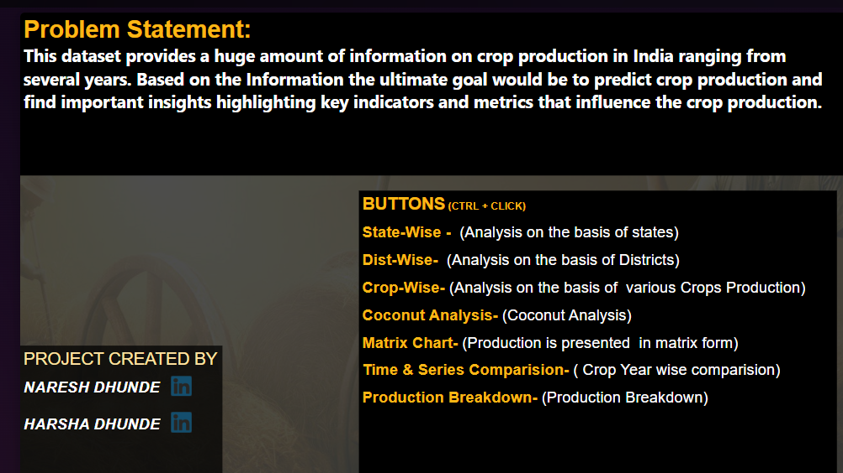

**STATE WISE ANALYSIS**

**This page shows:-**

* *Top 3 State by production , Cultivation area ,Avg production & cultivation*
* *Two Cards represent total production and total cultivation*
* *Clear filter clear all selected and reset filter resets all visualization*
* *We can filter out visualisation based on crop year , season*
* *Slicers represents zones which can be filtered for zonal wise representation*

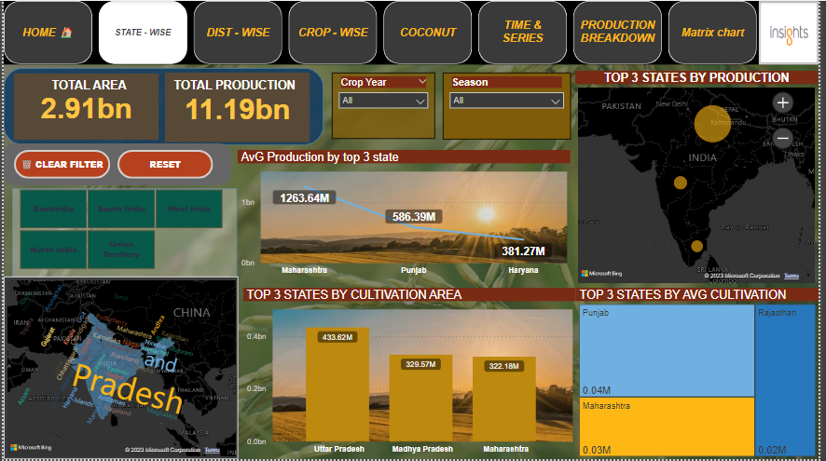

***Insight page of state wise production:-***

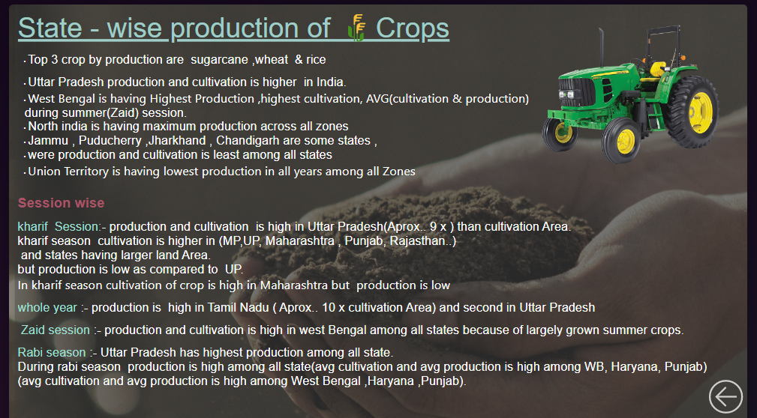

**DISTRICT WISE ANALYSIS**

**This page describes:-**

* *Top 3 Dist by production , Cultivation area ,Avg production & cultivation*
* *Two Cards represent total production and total cultivation*
* *Clear filter clear all selected from visualization*
* *We can filter out visualisation based on season with the help of buttons*

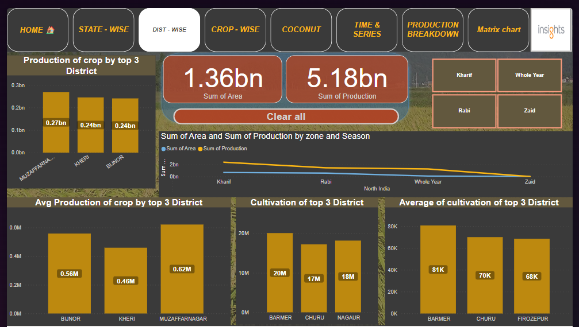

***Insight page of district wise production***

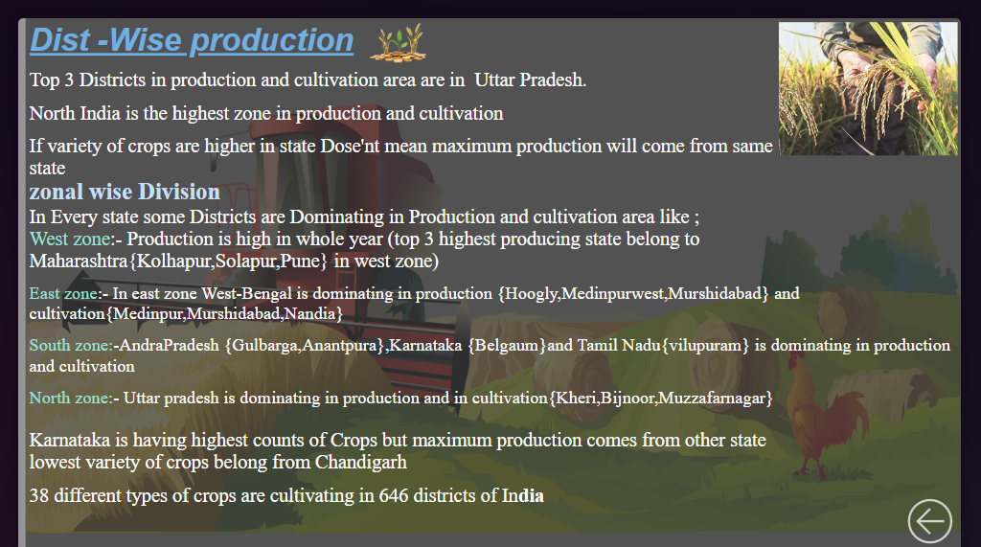

**CROP WISE ANAlYSIS**

**This page describes:-**

* *Top 3 crop by production , Cultivation area , Crop yield*
* *Four Cards represent total production , Number of crops , total cultivation , Total crops*
* *Clear filter clear all selected from visualization and crop year slicer filters data year wise*
* *We can filter out visualisation based on season & zones with the help of buttons*
* *Horizontal tables represents states production by crop year and production*

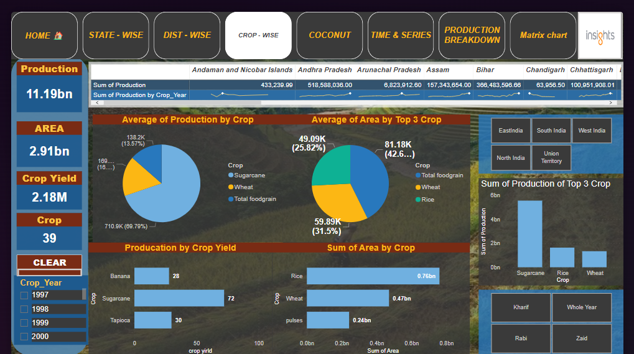

***Crop wise production insight***

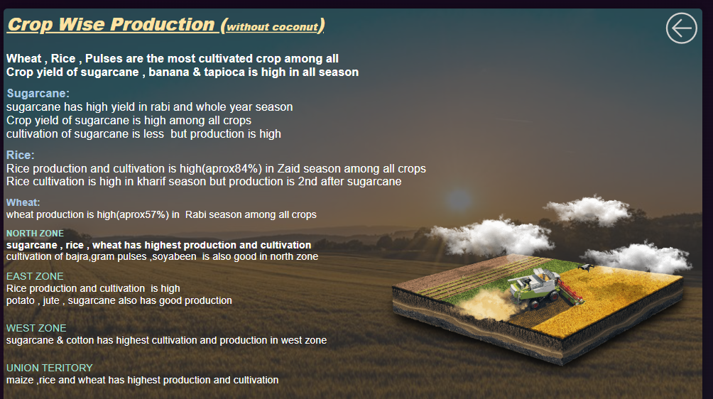

**Coconut Production Analysis**

***This page represents:-***

* *Total production of coconut*
* *Kharif and Rabi season wise coconut production*
* *Three Cards represent total production , total cultivation , Total crops*
* *Top States by production*
* *Waterfall chart of coconut – sum of production by crop year*
* *Year wise production and cultivation of coconut graph by line chart*

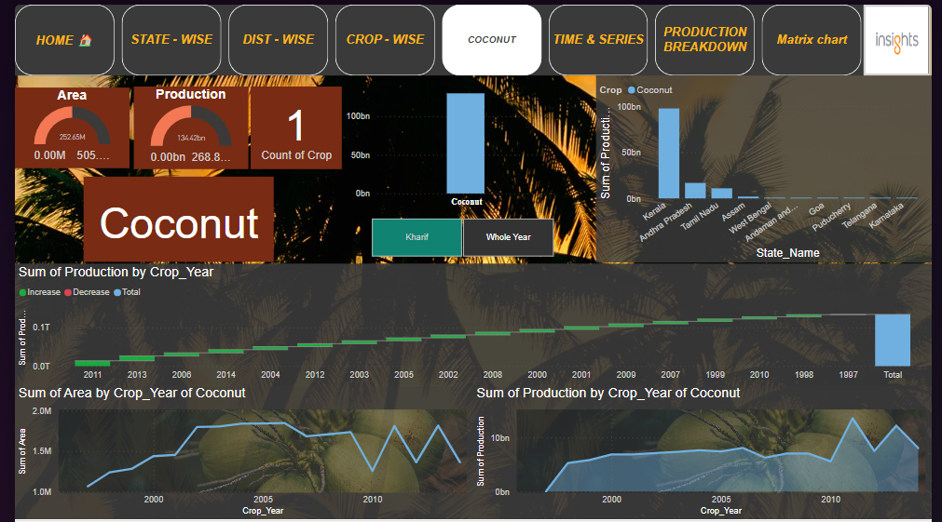

***Coconut insight***

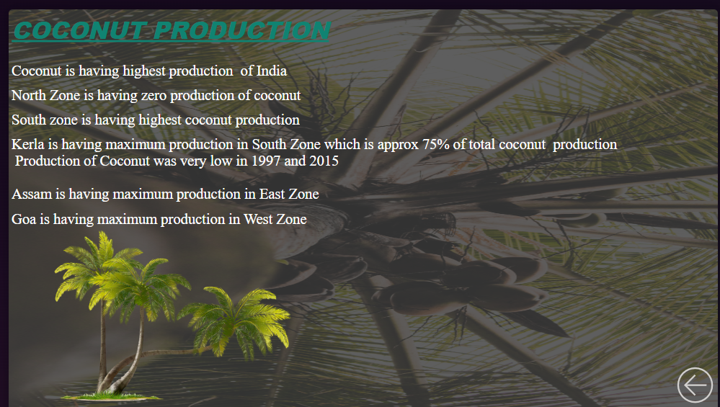

**Time & series wise Analysis**

***This page represents:-***

* *Time series of Yield*
* *Total production by crop year and season*
* *Time series analysis of total production v/s zone*
* *Filter for selecting zone wise visualization*

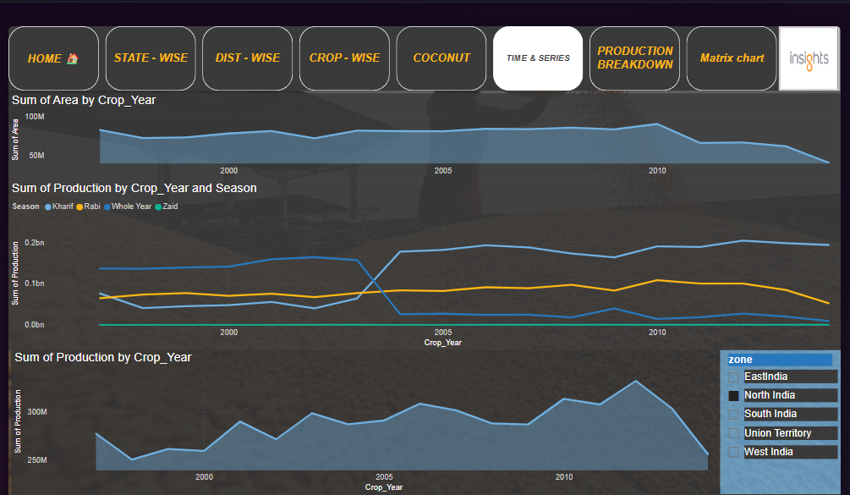

***Insight page of Time and Series***

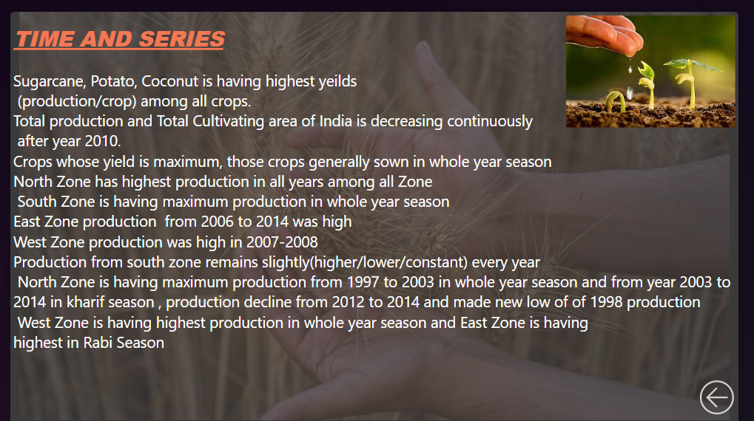

**Production breakdown**

***This page describe variation of production year by year***

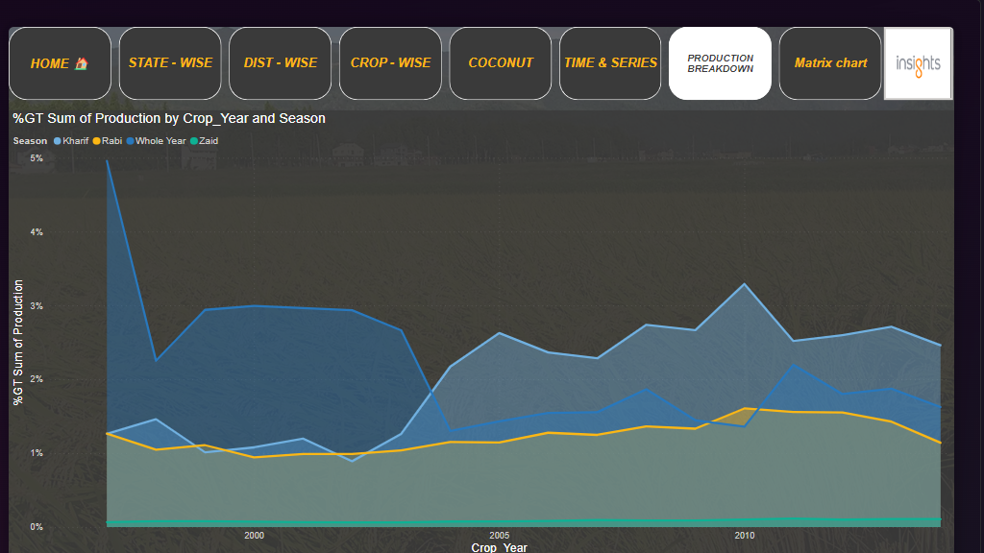

**Insight page of Production breakdown**

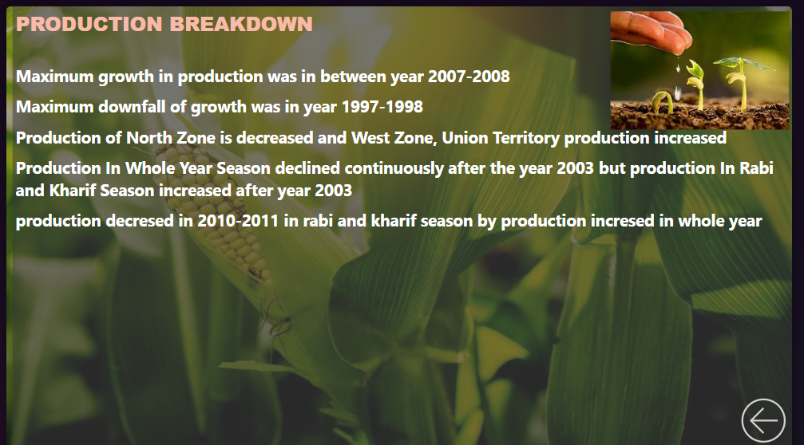

**Matrix Analysis**

***This page help us to understand how production of crop varies with different matrix***

